**Difference between container and container fluid:**

There are two container classes in bootstrap:

1. **.container**
2. **.container-fluid**

Let’s look at each of the above two classes in detail with examples:

**.container**: The .container class provides a responsive fixed width container.

**.container-fluid**: The .container-fluid class provides a full-width container which spans the entire width of the viewport.

**Grid System in Bootstrap:**

**Grid System:** Bootstrap Grid System allows up to 12 columns across the page. You can use each of them individually or merge them together for wider columns. You can use all combinations of values summing up to 12. You can use 12 columns each of width 1, or use 4 columns each of width 3 or any other combination.

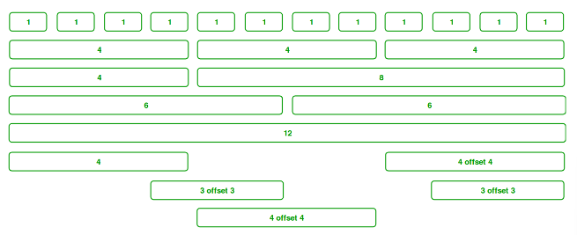

**The Bootstrap grid system has four classes:**

* xs (for phones - screens less than 768px wide)
* sm (for tablets - screens equal to or greater than 768px wide)
* md (for small laptops - screens equal to or greater than 992px wide)
* lg (for laptops and desktops - screens equal to or greater than 1200px wide)

**Navigation Bars:**

A navigation bar is a navigation header that is placed at the top of the page:

With Bootstrap, a navigation bar can extend or collapse, depending on the screen size.

A standard navigation bar is created with <nav class="navbar navbar-default">.

**navbar-inverse** change the colors of the navigation bar into inverted.